Ethan Stuart

SLL Homework

1. log(P(viewers>500|Temples)/P(viewers<500|Temples))= beta0 + beta1 Temples

Estimate Std. Error

(Intercept) -2.5847 0.7789

Temples 2.4343 0.7440

1. For a one number increase in Temples for a state (for example, moving from 1 to 2) we estimate the odds of viewership exceeding 500 increasing 11.41 times. (exp(2.4343)). # 95% confidence interval for that value being (3.386 72.080)
2. We rejected the hypothesis that number of temples (corresponds to member population) has no effect on Christmas devotional viewership for that state. Number of temples has a statistically significant effect on odds of viewership exceeding 500 (pvalue=0.0329, Chisquared value=-29.66).
3. 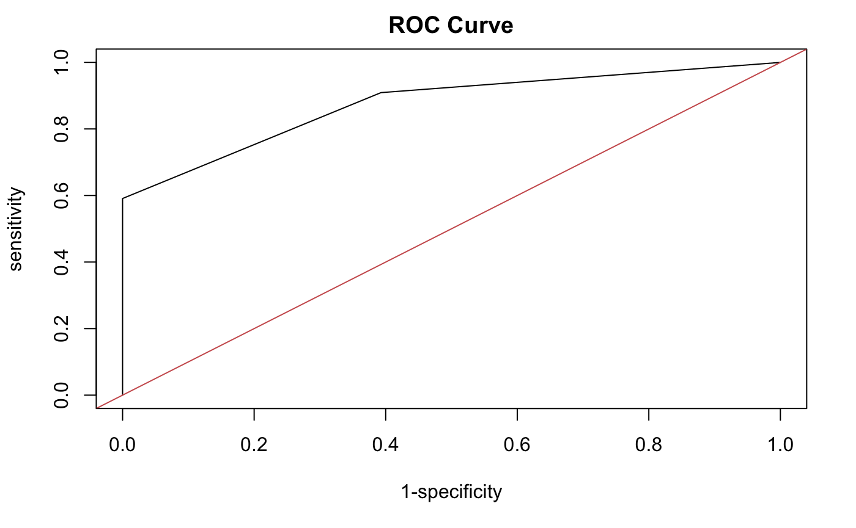
4. 0.8741883

6. Estimate =.4625, 95% CI (0.265, 0.660)